MN52080 Empirical Project 2

Introduction and Data Cleaning

This study investigates the dynamic relationship between the S&P 500 index and two key macroeconomic indicators: the Consumer Price Index (CPI) and the unemployment rate. The S&P 500, a widely used proxy for U.S. stock market performance, is influenced by broader economic conditions, particularly inflation and employment levels. Understanding how these variables interact is important for both investors and policymakers, as they directly affect investment strategies and economic decisions. Prior research, including Chen (2009), highlights the predictive power of macroeconomic variables during market fluctuations and downturns.

The aim of this study is to assess the nature and strength of the relationships between the S&P 500, CPI, and the unemployment rate over time. To do this, a range of time series methods were used: ARIMA models to explore univariate behaviour and forecasting potential; VAR models to examine interdependencies; and Granger causality and cointegration tests to assess causality and long-run equilibrium relationships. Each of these models offers a different perspective: ARIMA focuses on the internal structure of each series, VAR captures the dynamic interactions between variables, and the latter two explore directionality and long-term coherence.

CPI and the unemployment rate were chosen due to their prominence in both theory and empirical literature. CPI captures the inflation rate, a key driver of interest rates, costs, and market sentiment, while unemployment reflects broader economic health and consumer demand. Studies such as Brennan et al. (2004) and Mukherjee and Naka (1995) have established their relevance in explaining stock returns in both developed and emerging markets.

Monthly data from January 2000 to January 2025 were used to conduct the analysis. This 25-year window includes periods of expansion, recession, and financial instability, providing a rich environment for understanding macro-financial linkages. The dataset comprises:

* S&P 500 Index (^GSPC), sourced from Yahoo Finance, based on monthly closing prices.
* Consumer Price Index (CPIAUCSL), from FRED, representing seasonally adjusted inflation levels for all urban consumers.
* Unemployment Rate (UNRATE), from FRED, reflecting the seasonally adjusted U.S. civilian unemployment rate.

All data were merged using the monthly date index and checked for missing values to ensure temporal consistency and modelling accuracy. Prior to modelling, the time series properties of each variable were examined using unit root tests, specifically the Augmented Dickey-Fuller (ADF) test.

The level data for the S&P 500 and CPI were found to be non-stationary, consistent with financial time series that often exhibit trends or unit roots. To achieve stationarity, the S&P 500 and CPI were transformed using log-differencing, which stabilizes variance and removes exponential growth trends. The unemployment rate, also non-stationary in levels, was transformed using first differences. These transformations were necessary to meet the assumptions of stationarity required by ARIMA, VAR, and related models, and ensure reliable inference from the results.

The inclusion of these macroeconomic indicators is grounded in economic theory. Inflation affects firm profitability, discount rates, and investor sentiment, typically exerting downward pressure on stock returns when rising unexpectedly. The unemployment rate signals economic slack and consumer demand, with higher rates often correlating with weaker corporate earnings and lower equity valuations. Previous studies, including those by Rapach et al. (2005), suggest that macroeconomic indicators like CPI and unemployment have meaningful predictive power for market performance.

Based on these theoretical foundations, we expect CPI and unemployment to be inversely related to stock market performance. Preliminary visual inspection of the data supports these expectations: the S&P 500 and CPI show long-term upward trends, while unemployment displays more cyclical patterns and tends to rise during market downturns. These patterns motivate the use of time series techniques to formally assess both short-term dynamics and potential long-run equilibrium relationships.

ARIMA Modelling

In this part of the project, we used ARMA models to analyse the monthly behaviour of three key macro-financial time series: S&P 500 returns, CPI inflation, and the unemployment rate. The aim was to detect any short-term dynamics or predictable structures in these variables and establish a solid foundation for multivariate modelling later in the project.

We began with the S&P 500. Since stock prices are inherently non-stationary and exhibit a long-term upward trend, we modelled monthly percentage returns instead, in line with common practice in financial econometrics and the approach used by Rapach, Wohar, and Rangvid (2005). After transforming the data, the ADF test confirmed stationarity, supporting findings by Brennan, Wang, and Xia (2004), who show that financial returns typically satisfy stationarity conditions after differencing.

The ACF and PACF plots revealed small, short-lived autocorrelations, which is typical for financial returns. While the BIC suggested a white-noise process (ARMA 0,0), the AIC indicated an ARMA(2,2) model provided a better fit. Given the weak but present short-term structure, and consistent with the literature (Croux and Reusens, 2013), we opted for the more flexible ARMA(2,2), which allows for minor persistence while still maintaining parsimony.

For the CPI, we again avoided modelling the level of the index due to non-stationarity and instead used monthly inflation rates based on percentage changes. This transformation made the series more stable, and the ADF test confirmed stationarity. The ACF and PACF plots showed mild autocorrelation, particularly at lag 1, suggesting that recent inflation has some influence on current inflation. The AIC favoured an ARMA(1,1) model, which fits with economic theory, as inflation tends to evolve gradually rather than exhibiting abrupt jumps. This was also consistent with empirical findings by Chen (2009), who identified similar low-order dynamics in inflation data.

Next, we examined the unemployment rate. We modelled the monthly percentage change rather than the level, since unemployment tends to be slow-moving and non-stationary in levels. After differencing, the ADF test confirmed stationarity. Interestingly, the ACF and PACF plots showed almost no autocorrelation, and both AIC and BIC selected an ARMA(0,0) model. While initially surprising, this result aligns with the view that unemployment changes are often driven by sudden, external shocks or policy interventions, rather than smooth autoregressive dynamics. These patterns make such changes harder to model using standard time series techniques and support the idea that unemployment can behave like a white-noise process at high frequencies.

After fitting each model, we carried out diagnostic checks. In all cases, residuals resembled white noise, indicating that the models adequately captured the structure in the data. This diagnostic step is critical, as emphasised by Brockwell and Davis (2002), who stress the importance of validating models through residual analysis, not just in-sample fit.

While we recognise that ARMA models have limited forecasting power, particularly for financial returns, which are largely driven by unpredictable information shocks, the modelling exercise was still valuable. It helped us better understand the time series properties of each variable and highlighted where some short-term predictability exists. For instance, the weak but measurable autocorrelation in S&P 500 returns may inform short-horizon forecasting or volatility modelling, while the smoother CPI dynamics could play a role in understanding monetary policy responses. The apparent randomness in unemployment changes, meanwhile, points to the need for non-linear or event-driven approaches in modelling that variable.

To summarise, the ARMA(2,2) model provided a reasonable fit for S&P 500 returns, ARMA(1,1) was appropriate for CPI inflation, and ARMA(0,0) captured the dynamics, or lack thereof, in monthly unemployment rate changes. These findings are consistent with both theoretical expectations and empirical research, and they offer a clear starting point for the next phase of the project, where we will explore potential causal links among these variables and assess their broader macroeconomic implications.

Vector Autoregression (VAR) and Granger Causality

The purpose of this section is to apply a Vector Autoregressive (VAR) model to analyse the relationships among three key macroeconomic variables: the S&P 500 index (denoted as dsp), the Consumer Price Index (denoted as dcpi), and the unemployment rate (denoted as dur). These variables are essential for understanding the dynamics of financial markets and the broader economy. The analysis uses daily data, transformed into continuously compounded percentage returns and differenced to ensure stationarity.

The VAR model was estimated using the transformed stationary data for the variables **dsp, dcpi,** and**dur**, with a maximum lag length of 2. The results indicate that the optimal lag length is 2, as evidenced by the minimum values of the AIC and BIC, among other information criteria. The model was estimated using ordinary least squares (OLS), and a total of 296 observations were included in the estimation. The log-likelihood value is 1576.01.

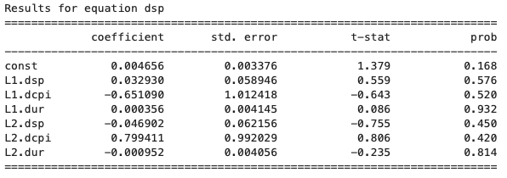

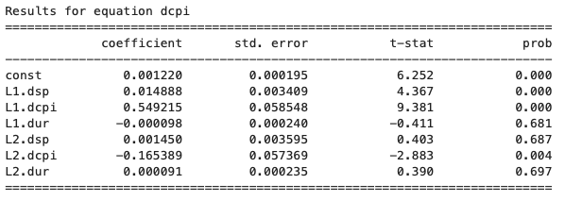

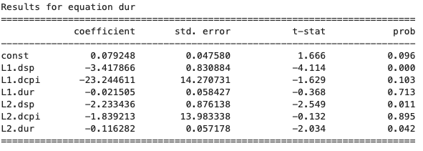

The full VAR model summary for each equation, including coefficients, standard errors, t-statistics, and p-values, is presented in the tables. Notably, in the dsp equation, the constant term is not statistically significant, and the lagged values of dsp, dcpi, and dur also show no significant effects. For the dcpi equation, the first lags of both dsp and dcpi are statistically significant, with coefficients indicating positive relationships. The second lag of dcpi is negative and statistically significant. In the dur equation, the first lag of dsp shows a significant negative relationship with dur, while the second lag of dsp also has a significant negative coefficient.

The BIC and AIC values are -18.7586 and -19.0204, respectively, suggesting a good model fit. These values, along with other criteria such as FPE and HQIC, confirm that the optimal lag length is 2, as indicated by the lowest values of the information criteria at this lag length.

Granger causality tests were conducted to determine the direction of causality between the variables in the VAR system. The null hypothesis for each test is that the "caused" variable does not Granger cause the "causing" variable. The results from the pairwise Granger causality tests are as follows:

For the relationship between the S&P 500 index and the Consumer Price Index, no Granger causality was found from CPI (dcpi) to the S&P 500 index (dsp) at the 5% significance level (p-value = 0.690). However, the S&P 500 index (dsp) does Granger cause CPI (dcpi) with a p-value of 0.000, suggesting that the S&P 500 index is a significant predictor of CPI.

For the relationship between CPI and the unemployment rate, no Granger causality was found from CPI (dcpi) to the unemployment rate (dur) (p-value = 0.852). Similarly, no Granger causality was found from the unemployment rate (dur) to CPI (dcpi) (p-value = 0.161).

For the relationship between the S&P 500 index and the unemployment rate, the S&P 500 index (dsp) does Granger cause the unemployment rate (dur) with a p-value of 0.000, indicating that stock market performance has predictive power over the unemployment rate. On the other hand, the unemployment rate (dur) does not Granger cause the S&P 500 index (dsp) at the 5% significance level (p-value = 0.969).

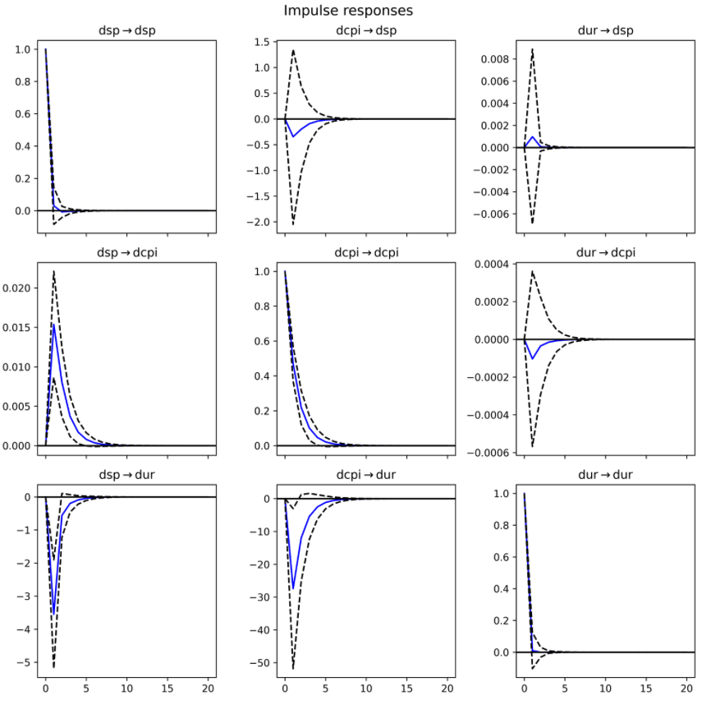

The IRF results show that the S&P 500 (dsp) reacts strongly and immediately to shocks, with a sharp drop followed by a gradual return to equilibrium. Its shocks also influence CPI (dcpi) and unemployment (dur), though with slower effects, suggesting markets lead economic indicators. In contrast, shocks to CPI cause only minor, delayed effects on the S&P 500, while unemployment shocks prompt a moderate, short-lived response in both financial and price variables. These patterns highlight the S&P 500’s dominant role in driving macroeconomic conditions, with limited feedback from CPI and unemployment.

FEVD results show that the S&P 500’s variance is almost entirely explained by its own shocks. CPI is also largely self-driven, though it increasingly reflects the influence of the S&P 500 over time. Unemployment variance is initially self-determined, but contributions from both CPI and the S&P 500 rise steadily, indicating growing sensitivity to economic and financial factors over time.

These results point to a strong internal self-determination in each of the variables, with financial markets (dsp) exerting some influence on both CPI and the unemployment rate, but the feedback loops are relatively weak.

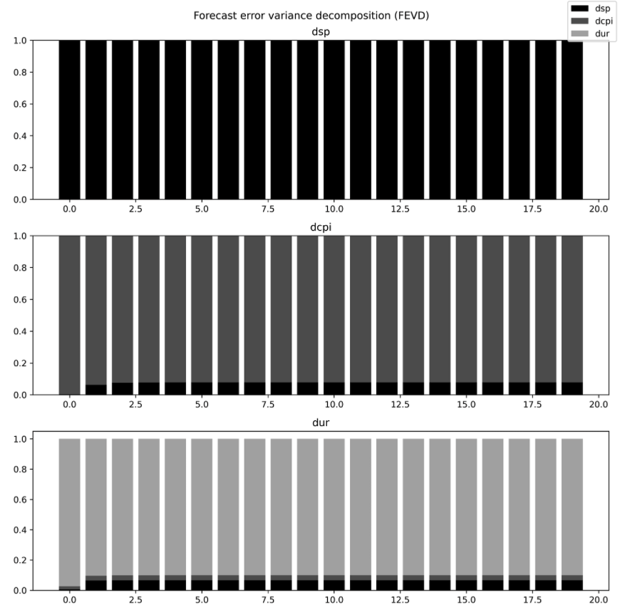 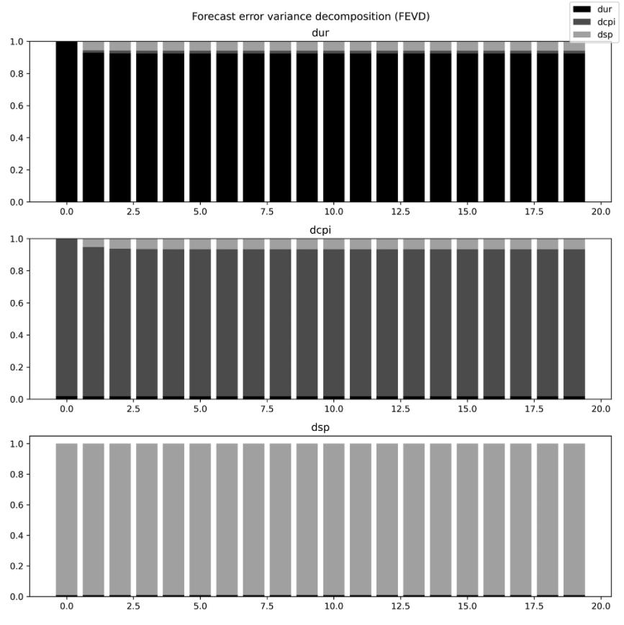

The VAR model analysis highlights the S&P 500 index as a key driver of both CPI and the unemployment rate, with the impulse response and variance decomposition showing its dominant role in these dynamics, especially in the short term. Granger causality tests confirm that the S&P 500 influences both CPI and the unemployment rate, but there is no direct feedback between CPI and unemployment. Sensitivity analysis shows that model specification, particularly variable ordering, can impact the results. Overall, the findings emphasize the significant influence of the S&P 500 on broader economic indicators, providing a basis for further economic research.

Cointegration and Long-Term Relationships

This section investigates the potential for cointegration among the S&P 500 Index, the Consumer Price Index (CPI), and the unemployment rate. We employ the Dickey-Fuller GLS unit root tests, the Engle-Granger two-step cointegration procedure, and the Johansen cointegration test to identify whether these variables share a stable long-run equilibrium relationship, suggesting deeper structural links within the economy. If cointegration is found, it would imply that despite short-term fluctuations, the variables move together in the long run.

Dickey-Fuller GLS

To assess pairwise cointegration, we first applied Dickey-Fuller GLs (DF-GLS) unit root test to the residuals from log-log OLS regressions. All series except the Unemployment Rate were log transformed. The test statistic for the residuals of the regression,

$$\log\left(S\&P 500\right)\sim log⁡(CPI)$$

was -0.798 (p=0.409), which is above the 5% critical value of -2.02, indicating that the residuals are non-stationarity. Similar results were obtained for the regressions:

$$\log\left(S\&P 500\right)\sim Unemployment$$

and $$\log\left(CPI\right)\sim Unemployment$$

These results imply that the residuals are non-stationary and that no cointegrating relationships exist between the variable pairs under this method.

Engle-Granger Cointegration Tests

To further assess the presence of long-term equilibrium relationships, the Engle-Granger two-step procedure was applied to each pair of variables:

$$\log\left(S\&P 500\right)\sim log⁡(CPI)$$

$$\log\left(S\&P 500\right)\sim Unemployment$$

$$\log\left(CPI\right)\sim Unemployment$$

The test evaluates whether the residuals from the cointegrating regressions are stationary, which would indicate the existence of a cointegrating relationship. The results were as follows:

|  |  |  |  |  |
| --- | --- | --- | --- | --- |
|  | Test statistic | P-value | 5% Critical Value | Conclusion |
| log(S&P 500) ~ log(CPI) | -2.62 | 0.230 | -2.98 | No cointegration |
| log(S&P 500) ~ Unemployment | -0.71 | 0.945 | -2.98 | No cointegration |
| log(CPI) ~ Unemployment | -0.66 | 0.951 | -2.98 | No cointegration |

In all cases, the test statistics do not exceed the 5% critical value (in absolute terms), and the p-values are well above conventional significant levels. As a result, we fail to reject the null hypothesis of no cointegration for all variable pairs. This suggests there are no long-term equilibrium relationships between these variables when considered pairwise.

These results reinforce the earlier findings from the Dickey-Fuller GLS test, indicating that none of the economic or financial variables are pairwise cointegrated. This is consistent with empirical literature, which suggests that while stock indices may be influenced by macroeconomic variables, they often reflect a broader set of market forces and expectations that are not captured in individual pairwise relationships (Fama, 1970; Chen, 2009).

Johansen Cointegration Test

To explore potential multivariate relationships, we applied the Johansen cointegration test using a lag length selected by the Akaike Information Criterion (AIC). The trace statistic for the null hypothesis of no cointegration (rank = 0) was 39.05, exceeding the 5% critical value of 35.01. The test for rank = 1 returned a trace statistic of 14.73, which is below the critical value of 18.40. This indicates that there is one cointegrating relationship among the three variables at the 5% level.

This result contrasts with the earlier bivariate tests and suggests that, although no individual variable pairs are cointegrated, the system as a whole exhibits a shared long-run equilibrium. This finding supports the theoretical view that macroeconomic and financial variables can evolve together in a coordinated manner over the long run, even if their pairwise relationships are weak or insignificant.

VECM Results and Economic Interpretation

Given that cointegration exists, we estimated a Vector Error Correction Model (VECM) with cointegrating rank 1. This model breaks down changes in each variable into short-run dynamics and breaks down adjustments toward long-run equilibrium.

Loading coefficients (α values) reveal how each variable responds to disequilibrium:

* For the Unemployment rate, the adjustment coefficient is -0.693 (p<0.001), which indicates a strong and significant tendency to revert to the long-run path, which suggests that when the system deviates from equilibrium, the labour market adjusts quick, likely reflects monetary policy response to inflation and output gaps.

* log(CPI) and log(S&P 500), α values are similar (0.0012 and 0.0160 respectively) and are statistically insignificant, which tells us that they are weakly exogenous and less responsive to correct imbalances.

The cointegrating equation estimated is:

This equation gives us a negative long-term relationship between CPI and stock prices, which is consistent and follows general economic theory. Rise in inflation typically causes increases in discount rates, reducing equity valuations. The positive coefficient on unemployment is less straightforward, potentially indicating countercyclical policy effects or specific model characteristics, especially in case of the volatility observed during the 2020 crisis.

Contrasting Methods and Implications

The differences in the results from the Engle-Granger and Johansen tests underscore the importance of the methodology used. The Engle-Granger test is limited to bivariate systems and overlooks interactions in multivariate data. In contrast, the Johansen test accounts for the joint dynamics of multiple variables, making it more suitable for identifying long-term relationships when the system's behaviour depends on multiple variable interactions, which is common in macroeconomics.

The existence of cointegration between the S&P 500, CPI, and the unemployment rate suggests that while short-term shocks may affect these variables independently, their long-term behaviour remains constrained by a shared equilibrium. For investors and policymakers, this implies that over time, equity markets tend to follow broader economic trends, rather than being driven purely by speculative activity or short-term factors.

The fact that unemployment is the variable that adjusts toward equilibrium most quickly indicates its fundamental role in economic stabilization. This finding supports economic theories that suggest labour markets bear the brunt of economic imbalances before stock prices respond.

In conclusion, while pairwise cointegration was not observed between the selected variables, the Johansen test reveals a significant multivariate cointegrating relationship. The VECM analysis further supports this, highlighting meaningful long-run corrective behaviour, particularly from the unemployment rate. These findings emphasize the importance of using multivariate techniques to uncover long-term relationships in macroeconomic data, providing valuable insights into how macroeconomic conditions influence stock market behaviour over time.

Final Reference List

 Brennan, M. J., Wang, A. W., & Xia, Y. (2004). Estimation and test of a simple model of intertemporal capital asset pricing. *The Journal of Finance*, 59(4), 1743–1776.

Brockwell, P. J., & Davis, R. A. (2002). *Introduction to Time Series and Forecasting*. Springer.

Chen, S.S., 2009. *Predicting the bear stock market: Macroeconomic variables as leading indicators*. Journal of Banking & Finance, 33(2), pp.211–223.

Croux, C., & Reusens, P. (2013). Do stock prices contain predictive power for future economic activity? A Granger causality analysis in the frequency domain. *Journal of Macroeconomics*, 35, 93–103.

Engle, R.F. and Granger, C.W.J., 1987. *Co-integration and error correction: representation, estimation, and testing*. Econometrica, 55(2), pp.251–276.

Eun, C.S. and Shim, S., 1989. International transmission of stock market movements. *Journal of Financial and Quantitative Analysis*, 24(2), pp.241–256.

Fama, E.F., 1970. *Efficient capital markets: A review of theory and empirical work*. The Journal of Finance, 25(2), pp.383–417.

Hogan, W.P., Sharpe, I.G. and Volker, P.A., 1982**.** Capital market efficiency and the relationship between equity returns, interest rates, and monetary aggregates in Australia. *Journal of Economics and Business*, 34(4), pp.377–385.

Hussain, S.M., 2011**.** Simultaneous monetary policy announcements and international stock markets response: An intraday analysis. *Journal of Banking & Finance*, 35(3), pp.752–764.

Johansen, S., 1988. *Statistical analysis of cointegration vectors*. Journal of Economic Dynamics and Control, 12(2-3), pp.231–254.

Mukherjee, T.K. and Naka, A., 1995. Dynamic relations between macroeconomic variables and the Japanese stock market: An application of a vector error correction model. *Journal of Financial Research*, 18(2), pp.223–237.

Rapach, D. E., Wohar, M. E., & Rangvid, J. (2005). Macro variables and international stock return predictability. *International Journal of Forecasting*, 21(1), 137–166.

Şendeniz-Yüncü, İ., Akdeniz, L. and Aydoğan, K., 2018**.** Do stock index futures affect economic growth? Evidence from 32 countries. *Emerging Markets Finance and Trade*, 54(2), pp.410–429.

**Appendix I**

**ACFI52080 Empirical Project 2 – Group Work**

**Group log**

(It is suggested you keep an online copy of this so team members can edit and read in real time).

|  |  |
| --- | --- |
| **Date** | **Event**  **(meeting / apologies (if not attend)/ incident / etc, anything noteworthy)**  **Provide brief description of what happened** |
| **23/03/25** | **Group meeting.All members present. Initial discussion held on project requirements, approach , and timeline planning.** |
| **02/04/25** | **Group meeting. All members present. Responsibilities and tasks were allocated across team members** |
| **14/04/25** | **Group meeting. All members present. Shared individual work and combined contributions via Google Drive. Progress reviewed.** |
| **1/05/25** | **All members present. Final checks, completed, formatted reviewed, and submission confirmed** |
|  |  |
|  |  |
|  |  |
|  |  |
|  |  |